Promote Short Video at on line “ + 1 Summit”

Free!
Free！
Free to promote your company and products at the “17th International Pharmaceutical Equipment & Technology Summit” - “+ 1 Summit” by the short video.
- Participant: International Pharma companies / pharmaceutical equipment manufacturers
- Promote Market: China and international Pharmaceutical Industry
- China Market on line Promote Channels:
- WeChat Xinxiao official video account“信销张瀞”; ( picture 1 )
- WeChat Firend Circle Xinxiao platform; ( picture 2)
- WeChat Group of each province of China Pharmaceutical industry（about 10,000 ) practitioners.
- China Audience: 4000+ Chinese pharma enterprises, R&D Centers, China whole pharma industry chain practitioners.
- International Market on line promote Channels:
- Linkedin Xinxiao Account
- Facebook Xinxiao Account
- Xinxiao Youtube Channel
- www.cnpharmalink.com - Xinxiao B2B business service platform for pharmaceutical whole industry for supply chain solution.
- Oversea Audience: thousands of pharma enterprises, R&D Centers, and trading companies
- Clothing Date: 2022/4/10
- Highlight: For new technology and machinery can allowed a speech video (about 10 - 30 minutes) with Chinese subtitles at “+1 Summit” on line platform to promote freely.

- Xinxiao profile:
Established Time: 2006
Business: service platform for whole Chain international pharmaceutical industry
Members: 300 + Chinese pharmaceutical equipment manufacturers

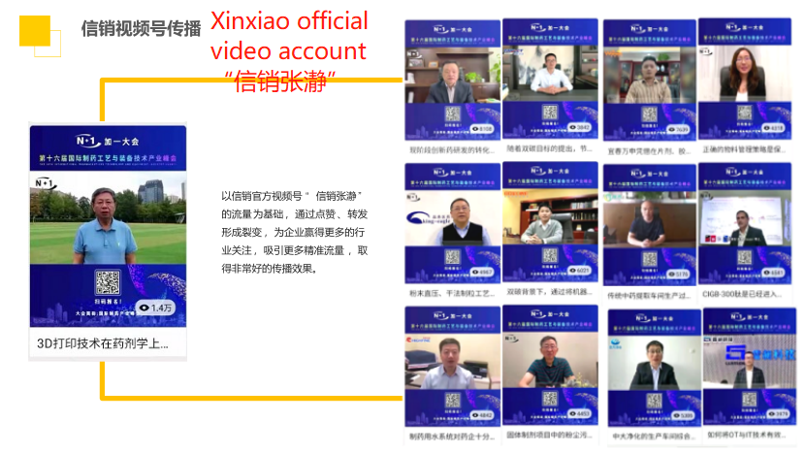
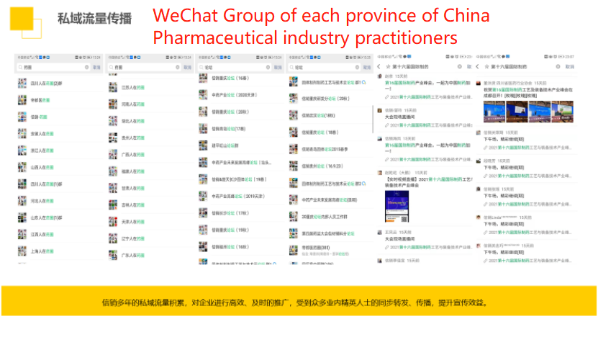

For free promotion, please follow our WeChat official account of the “Xinxiao Media” (“信销传媒” ) or find more information at www.cnpharmlink.com.
Please record a video in Chinese as required, other languages please with Chinese subtitles.
short video data submission form
Full Name
Company
Job Title
Phone No.
Email
Website
Video: Horizontal screen, close recording, less than 1 minute
【video reference】：
Hello, This is ... from ...(Country). We are ...(company name) produce/manufacture ...
(main products) for ... (application scope).
We are glad to join the on line “ + 1 summit” and wish the summit will be fully success!
[prompt]:
1. Background: logo wall/ workshop product side, etc
2. Company introduction: enterprise videos, product pictures and other contents are allowed
Video background sample:
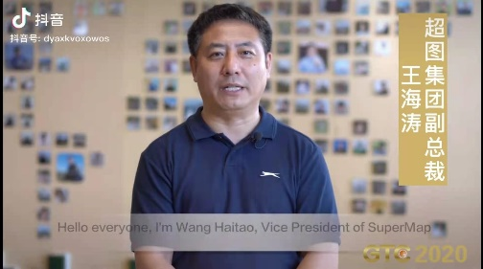
Please email the video to xinxiaolinda@cnpharmalink.com with title of video for + 1 summit or add WeChat account13373729391/ Whatsapp account: +86 13373729391.
Remark: The videos from you are agreed to edit by “ +1 summit” organizing committee.
Thanks!

